|  |  |  |  |
| --- | --- | --- | --- |
| Name | Date Submitted | Date Performed | Score |
| Group Members | | |
| Instructor | | Section |

**Prelab Quiz: Driven Oscillator**

**Read the manual** and answer the following questions.

1. Define natural frequency.
2. When is a system in resonance?
3. What is Hooke’s Law?

**Driven Oscillator**

**Objectives**

At the end of this activity you should be able to:

1. Measure the natural frequency of a spring-mass system.
2. Observe resonance by continuously driving a spring with a sinusoidal force.

**Introduction**

In everyday life, one will observe some objects which will have repeated motions about a fixed point, and this fixed point is the equilibrium position of the system. When these objects are disturbed from its equilibrium position that is when the repeated motion of the systems occurs. The repeated motion is technically called oscillation. One example that exhibits this behavior is the spring-mass system.

A system that oscillates has natural frequency. This natural frequency is the resonance frequency of the system if driven by a force. Resonance can be observed in daily life. For example, one can influence a playground swing to show the resonance behavior. An observer waits for the right time to push the swing so the swing will reach a higher height. When the timing is incorrect, the swing might even go to a lower height.

**Theory**

1. **Natural Frequency**

In this experiment, the experimenters will study the spring. The condition is that one end is hung vertically and the end that moves freely is facing the floor (See Figure1).

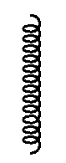



Mass = m

**Figure 1**. Relaxed positin of the spring

$$F_{Gravity}$$

.

**Figure 2**. A mass m is hang on one end of the spring. This is the new equilibrium position

Figure 1 is the relaxed position of the spring. In Figure 2, a mass m is now attached to one end of the spring which adds the effect of gravity to the system. Normally, the spring will go back to its equilibrium position because of the restoring force

$F= -k$ x [1]

(the negative sign just tells that the restoring force is opposite to the displacement of the spring from equilibrium, and k is the spring constant (N/m)) but gravity counter this force with equal magnitude but opposite in direction (the net force is zero).

The natural frequency for a given mass is given by

$$f= \frac{1}{2π}\sqrt{\frac{k}{m}}. [2]$$

Normally, there is damping force that will decrease the distance of oscillation until it reaches equilibrium. This is best described by a force that is proportional to the velocity, $\dot{x}$. The total force is now of the form

$$F= -kx-c\dot{x} [3]$$

Where c is a constant that determines the damping strength.

1. **Resonance**

Once an external force is applied, the equation of motion is now

$m\ddot{x}=-kx-c\dot{x}$ [4]

where $\dot{x}$ is velocity and $\ddot{x}$ is acceleration.

One of the objectives of this experiment is the observation of resonance. Once the natural frequency of the spring is known, what is left to do is to drive the spring with a force that is sinusoidal and with frequency that is equal to natural frequency. After sometime, the spring will have its steady state and will exhibit a resonance. For example, a sinusoidal driving force will have the equation of motion given by

$$m\ddot{x}=-kx-c\dot{x}+Fsinθ [5]$$

The steady state solution is

$$x\left(t\right)=A\left(ω\right)sin\left(ωt+β\left(ω\right)\right) [6]$$

Where A is the amplitude and $ω$ is the angular frequency.

The amplitude is given by

$$A\left(ω\right)=\frac{some constant}{\sqrt{{\left(ω_{natural}-ω\right)}^{2}-γ^{2}}}, [7]$$

and

$$γ= \frac{c}{2m}= \frac{1}{τ} [8]$$

where $τ$, is the phase.

The relation of phase, $φ$ and the driving frequency is now given by

$$φ=Arctan\left[-\frac{2ω}{ω_{0}^{2}-ω^{2}}\left(\frac{1}{τ}\right)\right]. [9]$$

**Materials**

**Speaker**

The speaker is where the driving force will come to move the spring-mass system.

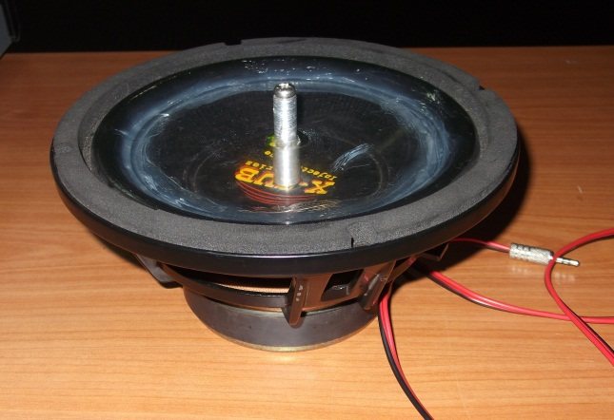

**Figure 3**. Speaker

**LabQuest**

LabQuest has a built in audio function generator which can produce a sinusoidal driving force to perturbate the spring mass system. Note that it is useful to know the natural frequency of the spring mass system for you to have the desired results.

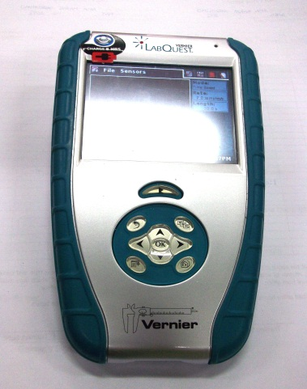

**Figure 4.** LabQuest

**Amplifier**

The amplifier increases the amplitude of oscillation which makes it easier for the ones doing the experiment to measure oscillation.

**Figure 5**. LabQuest

**Spring**

The spring is the most important part of the system because it is the one that will exhibit the oscillation behavior.

**Mass**

The mass should be heavy enough for the experimenter to measure the period of oscillation. The experimenters are encouraged to determine what the appropriate masses to be used in experiment are.

**Procedure**

1. **Natural Frequency**

Case 1.

1. Select different masses for the experiment. (more than 3)

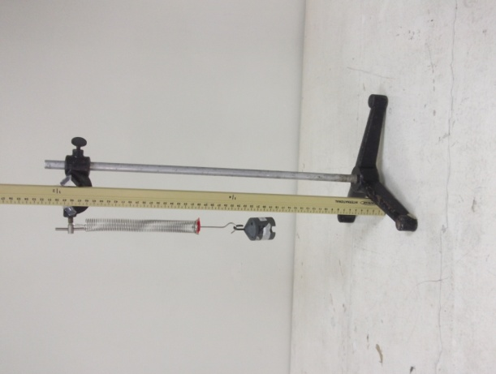

**Figure 6**. A spring-mass system with a meter stick to measure the displacement from equilibrium.

1. Mark the equilibrium position of the spring. Record the position on the data sheet.
2. Hang each mass to the hook of the spring. Record its displacement from equilibrium on the data sheet.
3. Compute the spring constant with the hint that the slope of the graph of Force vs. the inverse of displacement is k/g, where g is the acceleration due to gravity.
4. For a given mass m, the natural frequency can be calculated using

$f= \frac{1}{2π}\sqrt{\frac{k}{m}}$. [10]

1. Compute for the frequency of the 200 g mass and use the same mass for the rest of the experiment. This mass will also be used for Part B of the experiment.

**B.**    **Resonance**

Resonance can be observed by determining the natural frequency of the spring. Considering a range of driving frequencies for the spring is good precursor in observing resonance. Here, one will observe the peculiarity of the spring’s response when it is driven at its own natural frequency.

Set-Up

**Figure 7**. Schematic Diagram of the Set-Up



Speaker

Amplifier

Signal Generator

Mass = m

**Figure 8**. Spring-Mass system drive by a speaker

Speaker

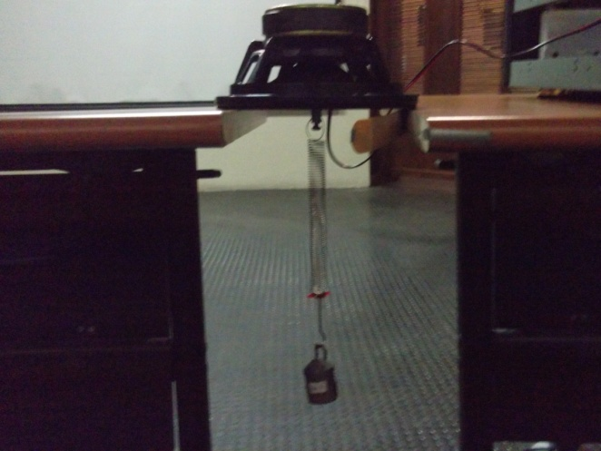

Spring

Mass

1. Attach the spring to the speaker [facing the ground.
2. Attach 200g mass at one end of the spring.
3. Connect the Speaker to the amplifier.
4. Connect the LabQuest to the amplifier.

**Caution:** Replace caution note with: The sound coming from the speaker might be intolerable. Adjust the volume on the amplifier as preferred and keep constant all throughout the experiment.

1. In LabQuest, go to the Audio Function Generator application. This is where you customize the driving frequency.
2. Test the speaker if it oscillates.

1.   After determining the natural frequency in Part A, a range of frequency near and including the natural frequency should drive the spring. Maintain constant amplitude of the driving frequency in Lab Quest Function Generator for each session of driving the speaker.

2.   For the each session of driving the speaker with a particular frequency, record the maximum and minimum displacement of the mass from equilibrium using a meter stick in the data sheet provided.

3.   Plot the displacement of the mass vs. frequency.

4. Plot the phase vs. frequency using equation 9. Use the maximum and minimum recorded damping time, the natural frequency and the range of frequencies tested.

|  |  |  |  |
| --- | --- | --- | --- |
| Name | Date Submitted | Date Performed | Score |
| Group Members | | |
| Instructor | | Section |

Worksheet: Driven Oscillator

1. **Natural Frequency**

**Table 1**. Displacement from Equilibrium for each Mass

|  |  |
| --- | --- |
| Displacement (meters) | Mass (kilograms) |
|  |  |
|  |  |
|  |  |
|  |  |
|  |  |
|  |  |
|  |  |
|  |  |
|  |  |
|  |  |
|  |  |
|  |  |

**Data Graph 1**. Displacement (meters) vs Mass (kilogram)

Displacement (meters)

Mass (kilogram)

Best estimate of spring constant: ___________

Equilibrium Position: ___________

Natural Frequency (200 g): _______________

1. **Resonance Frequency**

**Data Graph 2**. Equilibrium Displacement (meters) vs. Frequency (Hz)

Displacement (meters)

Frequency (Hz)

Natural Frequency (200 g): _______________

**Data Graph 3**. Phase (Degrees) vs. Driving Frequency (Hz)

­­

Phase (Degrees)

**Questions.**

Frequency (Hz)

Minimum time of damping: ____________

Maximum time of damping**: ____________**

**Calculations:**

**Questions**

1. Why do we need to use a mass of 200 g? Why not 5 g?
2. Suppose the spring-mass system will be driven automatically by hand, is it possible to oscillate it with its natural frequency?

3. What is the source of damping in the system?